DEVELOPING AN INTELLIGENT GRADUATE TO JOB MAPPING SYSTEM, A CASE STUDY OF TUK

STUDENT NAME: [LEWIS KARIUKI]

STUDENT NUMBER: [AIIM/00477/2021]

A RESEARCH PROJECT SUBMITTED IN PARTIAL FULFILMENT OF THE REQUIREMENTS FOR BACHELOR OF SCIENCE IN INFORMATION SCIENCE

IN

DEPARTMENT OF INFORMATION SCIENCE, LANGUAGE, AND COMMUNICATION STUDIES

FACULTY OF SOCIAL SCIENCE AND TECHNOLOGY

OF

TECHNICAL UNIVERSITY OF KENYA

DECEMBER 2026

DECLARATION.

I declare that this proposal is my original work and, to the best of my knowledge, has not been submitted for the award of a degree at any other institution

SIGN __________________________DATE________________________________
LEWIS KARIUKI
AIIM/00477/2021.

This proposal has been reviewed and approved by us in our capacity as university supervisors for the Bachelor of Science in Information Science degree.

SIGN __________________________DATE________________________________
Mr. JACKSON ALUNGA
Department of Information Science, Language, and Communication Studies.

ACKNOWLEDGMENT
I want to express my heartfelt gratitude to my family and friends for their unwavering support, encouragement, and understanding throughout the development of this research proposal. Their belief in my abilities has kept me motivated and focused during challenging times.
I am also grateful to my supervisors and mentors for their invaluable insights and guidance, which greatly enhanced the quality of my work. Your encouragement and constructive feedback have been instrumental in shaping this proposal.
Additionally, I would like to thank my fellow students and peers who engaged in discussions, provided feedback, and shared ideas all of which contributed to the refinement of my research. Your camaraderie and support made this journey much more enriching.
Lastly, I appreciate the various online communities and academic resources that offer essential information and guidance throughout the research process. Your contributions have been crucial to my project's development.
Thank you all for being an integral part of this journey.

TABLE OF CONTENTS
DECLARATION.
ACKNOWLEDGMENT
TABLE OF CONTENTS
LIST OF ABBREVIATIONS AND ACRONYMS
ABSTRACT
1.0 CHAPTER ONE: INTRODUCTION
1.1 BACKGROUND OF THE STUDY
1.2 CONTEXT OF THE STUDY
1.3 STATEMENT OF THE PROBLEM
1.4 AIM OF THE STUDY
1.5 RESEARCH OBJECTIVE
1.6 RESEARCH QUESTIONS
1.7 ASSUMPTION OF THE STUDY
1.8 SIGNIFICANCE OF THE STUDY
1.9 JUSTIFICATION OF THE STUDY
1.10 SCOPE OF THE STUDY
1.11 LIMITATIONS OF THE STUDY
2.0 CHAPTER TWO: LITERATURE REVIEW
2.1 INTRODUCTION
2.2 THEORETICAL FRAMEWORK
2.2.1 Kolb’s Experiential Learning Theory (ELT)
2.2.2 Theory of Perceived Value
2.3 EMPIRICAL LITERATURE REVIEW
2.3.1 The Employability Gap and the Skill Translation Deficit
2.3.2 Using Artificial Intelligence for Skill Extraction and Visualisation
2.3.3 The Gig Economy and Youth Employability in Kenya
2.3.4 Categorisation of University Acquired Skills
2.4 SUMMARY OF GAPS IN LITERATURE
3.0 CHAPTER THREE: RESEARCH METHODOLOGY
3.1 INTRODUCTION
3.2 RESEARCH METHOD USED
3.3 TARGET POPULATION OF STUDY
3.4 SAMPLE SIZE AND SAMPLING TECHNIQUE
3.5 DATA COLLECTION TOOLS
3.6 DATA COLLECTION PROCEDURE
3.7 DATA ANALYSIS
4.0 CHAPTER FOUR: SYSTEM METHODOLOGY
4.1 INTRODUCTION
4.2 SYSTEM DESIGN AND DEVELOPMENT METHODOLOGY
4.3 SYSTEM ARCHITECTURE
4.4 TECHNICAL TOOLS AND FRAMEWORKS
4.5 IMPLEMENTATION TECHNOLOGIES
4.5.1 Machine Learning (Classification, Clustering, and Ranking Algorithms)
4.5.2 Natural Language Processing (NLP)
4.5.3 Knowledge Graphs
4.5.4 Data Analytics
4.5.5 Application Programming Interfaces (APIs)
4.6 CONCLUSION
5.0 CHAPTER FIVE: DATA ANALYSIS AND FINDINGS
INTRODUCTION
5.1 RESPONSE RATE AND DEMOGRAPHIC PROFILE OF RESPONDENTS
5.2 FINDINGS RELATED TO SYSTEM USAGE AND ACADEMIC DOCUMENT AVAILABILITY
5.3 FINDINGS RELATED TO THE EMPLOYABILITY GAP AND SKILL TRANSLATION
5.4 FINDINGS RELATED TO DASHBOARD FUNCTIONAL REQUIREMENTS AND PERCEIVED VALUE
5.5 SUMMARY OF KEY FINDINGS
6.0 CHAPTER SIX: SYSTEM IMPLEMENTATION
6.1 INTRODUCTION
6.2 USER AUTHENTICATION AND ONBOARDING
6.3 SYSTEM NAVIGATION AND INITIALISATION
6.4 DATA INPUT AND AI PROCESSING
6.5 SYSTEM OUTPUT: THE CAREER MAPPING DASHBOARD
6.6 SUMMARY
REFERENCES

LIST OF ABBREVIATIONS AND ACRONYMS

Abbreviation/Acronym | Full Term
A
AI | Artificial Intelligence
API | Application Programming Interface
B
BI | Business Intelligence
C
CSS | Cascading Style Sheets
CSV | Comma-Separated Values
D
DSR | Design Science Research
E
ELT | Experiential Learning Theory
ERD | Entity Relationship Diagram
F
FAST | Faculty of Applied Sciences and Technology
FEBE | Faculty of Engineering and the Built Environment
FSST | Faculty of Social Sciences and Technology
H
HTML | HyperText Markup Language
I
ICT | Information and Communication Technology
IP | Intellectual Property
J
JS | JavaScript
L
LLM | Large Language Model
M
MVP | Minimum Viable Product
P
PWA | Progressive Web App
R
REST | Representational State Transfer
S
SDLC | Software Development Life Cycle
SPSS | Statistical Package for the Social Sciences
SQL | Structured Query Language
SUS | System Usability Scale
T
TU-K | Technical University of Kenya
U
UI/UX | User Interface / User Experience
UML | Unified Modelling Language

ABSTRACT
Globally, universities face increasing pressure to produce graduates who are ready for the modern workforce. In Kenya, there is a significant gap between the theoretical knowledge students learn in class and the practical skills employers need. Research shows that helping students connect their coursework directly to real-world jobs is crucial for improving their success after graduation (Jackson et al., 2024). To solve this problem, this project aims to develop an intelligent mapping system that translates the skills acquired by students at the Technical University of Kenya (TUK) into marketable service offerings.
Instead of relying on traditional analysis tools, this system uses Llama, a pre-trained, open-source Large Language Model (LLM). The system is designed to automatically read and process a student's academic documents, including transcripts, certificates, project reports, and assignments. Guided by Kolb’s Experiential Learning Theory (Kolb, 1984), which emphasises applying learned concepts to real-world situations, the LLM will analyse these documents to build a visual profile dashboard. This dashboard will clearly show who the student is, the specific skills they have gained, and the concrete services they can offer to the gig economy based on their education. When students see the practical value of their education, their overall satisfaction and engagement improve significantly (Iskandar et al., 2024).
The study will use a mixed-methods approach, gathering both qualitative and quantitative survey data. To ensure the system accurately captures a range of technical skills, the research targets a sample of 150 students from TUK's faculties, including FSST, FEBE, and FAST. The system will be trained on this specific TUK course and student data to ensure accuracy.
By turning academic tasks into a list of real-world services, the platform encourages students to think like entrepreneurs (Jones et al., 2021). Ultimately, the findings will offer a scalable, technology-driven solution that goes beyond the university. The long-term goal is for this system to be adopted by the Kenya's Ministry of Labour to help bridge the national youth employability gap and align academic training with industry needs.

Keywords: Intelligent Mapping System, Large Language Models (LLM), Llama, Employability Gap, Profile Dashboard, Experiential Learning, Ministry of Labour Kenya, Technical University of Kenya (TUK).

1.0 CHAPTER ONE: INTRODUCTION

1.1 BACKGROUND OF THE STUDY
In recent years, higher education institutions faced growing pressure to produce graduates who were not just academically proficient, but also practically prepared for the modern workforce. Employers increasingly sought candidates who could solve real-world problems immediately upon recruitment. However, despite acquiring strong theoretical knowledge and completing numerous academic projects, graduates often struggled to translate classroom learning into practical services that could be offered to potential employers. This disconnect created a severe employability gap.
In Kenya, this problem has remained highly significant, each year, only about half of graduating students are considered suitable for the job market due to a distinct lack of practical exposure. A report by the Technical University of Kenya (2015) highlighted that employers strongly preferred graduates with hands-on, practical training. Similarly, Kimeu (2019) pointed out that many graduates faced substantial challenges when transitioning from university to the workplace because they were not adequately prepared for professional demands. Consequently, most employers found that new graduates required additional training before becoming truly productive within an organisation.
Historically, there was a total lack of structured, data-driven systems capable of automatically evaluating a student's specific academic documents, such as transcripts, certificates, project reports, and assignments. Students lacked a dedicated tool to connect theoretical knowledge to applied skills, which would allow them to transition from abstract classroom concepts into active, real-world practice. This study directly addressed this technological void by developing an intelligent mapping system that translated the skills acquired by students at the Technical University of Kenya (TUK) into practical, marketable service offerings.
To achieve high-speed inference and accurate semantic understanding, the project utilised an open-source Llama Large Language Model (LLM) integrated via the Groq API.
The LLM read and processed the students' unstructured academic documents to automatically design a personalised profile dashboard. This dashboard clearly visualised the student's professional identity, the specific skills they had acquired, and the concrete services they could offer to the gig economy based on their education.
The system was initially configured and evaluated using course and student data collected directly from TUK faculties to ensure the correct format and structural accuracy in populating the portfolio dashboard. Provisions were also established to adapt the system engine for future hosting on selected public sectors, most notably Kenya’s Ministry of Labour.
By demonstrating exactly how academic skills could be translated into actionable services, the project succeeded in boosting students' confidence regarding their own employability. Ultimately, this research developed a scalable solution designed with the long-term goal of national adoption by the Ministry of Labour in Kenya, thereby successfully bridging the gap between academia and the contemporary job market on a national scale.

1.2 CONTEXT OF THE STUDY
In the changing landscape of higher education, graduates are expected to be both knowledgeable and practically equipped for their careers. The Technical University of Kenya (TUK) played a major role in producing graduates who were ready to solve real-world problems. According to the university's records, the graduating class of that period consisted of 2,277 students (Technical University of Kenya, 2025). These students possessed unique technical competencies across various departments, specifically the Faculty of Applied Sciences and Technology (FAST), the Faculty of Social Sciences and Technology (FSST), and the Faculty of Engineering and the Built Environment (FEBE).
Despite this academic success, there was a major disconnect between what students learned in class and the practical experience employers expected. While students gained strong theoretical knowledge and completed many academic projects, they often struggled to turn this classroom learning into specific services they could offer in the job market. This gap created significant challenges for graduates seeking work. In Kenya, although about 50,000 students graduated each year, only half were considered employable because they lacked practical skills (Đorđević et al., 2025). Furthermore, while many young people were turning to the gig economy for income, they often did not know how to translate their specific university degrees into freelance work (Wanjiru, 2025).
A major reason for this struggle was the lack of proper technological tools within the university ecosystem. At the time of the study, there was no structured system capable of automatically evaluating a student's full academic portfolio, including transcripts, certificates, project reports, and assignments. Because they could not easily map their academic achievements to practical services, many students found it hard to show prospective employers or clients what they could actually do. This significantly contributed to their employment struggles and fuelled the belief that there were simply no jobs available (Adekunle, 2025).
To solve these challenges, this study developed an intelligent mapping system that translated the skills TUK students acquired into marketable service offerings. Moving away from older, rigid data analysis tools, this system utilised an open-source Llama Large Language Model (LLM) accessed via the Groq API (version 1.0). This API integration provided high-speed data processing and semantic analysis capabilities. Configured with TUK's specific course structures and student data, the LLM automatically read and processed unstructured text from student documents. It then generated a personalised profile dashboard that clearly visualised who the student was, the skills they had acquired, and the specific, marketable services they could offer based on those skills.
By visualising their academic skills as actionable services, the system successfully boosted students' confidence and helped them prepare to actively participate in the modern workforce. This approach directly responded to employer demands by bridging the gap between classroom training and practical application. Ultimately, the project's vision extended beyond the university; the long-term goal was for this system to be adopted by the Ministry of Labour in Kenya to guide national workforce development and successfully transition graduates into the digital economy.

1.3 STATEMENT OF THE PROBLEM
Historically, many students at the Technical University of Kenya (TUK) graduated with strong theoretical knowledge but struggled to translate their coursework and projects into practical, marketable services. This disconnect contributed to a severe employability gap in Kenya, as employers increasingly demanded candidates who could immediately apply their skills to solve real-world problems (Jackson et al., 2024). The root of this problem was the lack of a smart tool that could automatically analyse a student’s specific academic documents such as transcripts, certificates, project reports, and assignments to identify their professional value. Although alternative job platforms existed, they failed to help graduates who did not yet know how to define their skills as services, leading to a difficult transition into the traditional workforce or the gig economy (Wanjiru, 2025).
This study addressed this technological void by developing an intelligent mapping system powered by an open-source Llama Large Language Model (LLM) integrated through the Groq API (version 1.0). Tailored using TUK faculty and student data, the system successfully generated a visual profile dashboard that clearly showed who the student was, the skills they had acquired, and the specific services they could offer. By moving students from abstract theory to "active experimentation" (Kolb, 1984), this project provided a scalable solution designed to help the Ministry of Labour improve graduate outcomes and bridge the gap between university training and national industry needs.

1.4 AIM OF THE STUDY
The primary aim of this study was to develop an intelligent mapping system that translated the academic skills acquired by students at the Technical University of Kenya (TUK) into practical, marketable service offerings. Utilising an open-source Llama Large Language Model (LLM) integrated via the Groq API (version 1.0), the system was configured using specific TUK faculty course data and student records. The platform was engineered to automatically process and analyse a variety of unstructured academic documents, including transcripts, certificates, project reports, and assignments, to successfully identify the professional competencies contained within them.
The core output of the system was a personalised profile dashboard that visualised the student's professional identity, the specific skills they had mastered, and the concrete services they could offer in the gig economy based on those skills. By transforming abstract classroom learning into "active experimentation" (Kolb, 1984), the system successfully sought to bridge the employability gap and increase the perceived value of university education (Iskandar et al., 2024). Ultimately, this project provided a scalable, data-driven tool designed with the long-term goal of adoption by Kenya’s Ministry of Labour to effectively align national youth skills with the evolving demands of the modern job market.

1.5 RESEARCH OBJECTIVE
- To determine the functional and system requirements for a Llama-based intelligent skill-to-service mapping engine, focusing on how to effectively process data from student transcripts, certificates, project reports, and assignments.
- To identify and categorise the specific technical and theoretical skills taught across TUK’s main faculties (FAST, FEBE, and FSST) to ensure the system is accurately trained on relevant university course data.
- To identify and analyse current employer requirements and gig-economy market demands to ensure that the system maps student skills to highly sought-after industry services.
- To develop the Intelligent Mapping System using the pre-trained, open-source Llama Large Language Model (LLM) to translate academic achievements into a visual profile dashboard.

1.6 RESEARCH QUESTIONS
- What specific data from student documents such as transcripts, certificates, project reports, and assignments must be processed by the Llama model to create an accurate list of a student's university-acquired skills? (Jackson et al., 2024).
- How can the Llama Large Language Model be designed and trained using TUK faculty and course data to effectively translate academic records into visual profile dashboard?
- In what ways does a visual dashboard of marketable services help students move from theoretical learning to "active experimentation" in the real world? (Kolb, 1984).
- How does having a clear map of marketable services impact a student's confidence and the "perceived value" of their university education? (Iskandar et al., 2024).
- How can this intelligent mapping system be scaled to provide the Ministry of Labour in Kenya with a data-driven tool to bridge the national employability gap? (Đorđević et al., 2025).

1.7 ASSUMPTION OF THE STUDY
This study was based on several important assumptions that are necessary for the success of the intelligent mapping system. First, it was assumed that student documents such as transcripts, certificates, project reports, and assignments, contain sufficient detail for the Llama Large Language Model to accurately identify and categorise a student's technical skills (Jackson et al., 2024). Second, the study assumed that it is technically possible to use this AI model to translate academic achievements into clear, professional service offerings that make sense in the modern job market.
Third, the research assumed that the courses taught in TUK’s FAST, FEBE, and FSST faculties are relevant enough to current industry needs to be turned into valuable services (Đorđević et al., 2025). On a human level, it is assumed that students will find the visual profile dashboard useful and that seeing their skills mapped out this way will increase their confidence and the "perceived value" of their degree (Iskandar et al., 2024).
Furthermore, the study assumed that training the system on TUK-specific data will make the model sufficiently accurate to be adopted by the Ministry of Labour as a national tool for improving graduate employment. Finally, the research relied on the assumption that the 150 students participating in the study will provide honest and accurate information during the testing and evaluation of the platform (Kolb, 1984).

1.8 SIGNIFICANCE OF THE STUDY
The findings of this study will be highly valuable to several groups by providing a smart way to connect university learning with real-world jobs. By using the Llama Large Language Model to map skills, the project offers a modern solution to the long-standing problem of graduate unemployment in Kenya (Kimeu, 2019).
To university students, this study will provide a direct way for students to see the real market value of their hard work. By using the intelligent mapping system to analyse their transcripts, certificates, project reports, and assignments, students can move past just learning theory. The profile dashboard will show them exactly which services they can offer to the gig economy (Jones et al., 2021). This not only boosts their confidence but also gives them a way to earn money and gain work experience while they are still in school, helping them become more "market-ready" (Jackson et al., 2024).
To Higher education institutions (specifically TUK) the study offers a scalable model for using Artificial Intelligence to improve the student experience. It shows how TUK can use the Llama model to check if its courses are staying relevant to what employers actually need (Đorđević et al., 2025). By adopting this system, the university can better track how well its departments are preparing students for jobs. This increases the "perceived value" of a TUK degree, making the institution more attractive to both new students and industry partners (Iskandar et al., 2024).
To the Ministry of Labour and policymakers, this research will provide a data-driven tool to help manage the "jobless economy" through technology. Since the system is trained on TUK faculty data, it offers a blueprint that the Ministry of Labour can adopt on a national level. Policymakers can use these insights to align Kenya’s education goals with the demands of the digital labour market, ensuring that the skills students learn in class are the same ones needed to grow the national economy (Wanjiru, 2025).
To the academic community, this study will add to the growing research on the "Future of Work" and how AI can be used in education. It combines Kolb’s Experiential Learning Theory (Kolb, 1984) with the Theory of Perceived Value in a new way. By showing how a Large Language Model can automatically map skills to services, it provides a foundation for future researchers to explore how technology can bridge the gap between academia and professional practice in many different fields.

1.9 JUSTIFICATION OF THE STUDY
The justification for this study was based on the urgent need to fix the mismatch between university training and the practical needs of the modern job market. While the Technical University of Kenya (TUK) produces thousands of skilled graduates every year, there is a "translation gap." Students often have the right skills but do not have a way to turn those skills into services that people want to buy. In today’s "jobless economy," simply having a degree is often not enough; the ability to offer specialized services as a freelancer is becoming the main way for young people to enter the workforce (Wanjiru, 2025).
This study is specifically justified because it moved beyond traditional job directories by using the Llama Large Language Model (LLM). Most freelance platforms assume that a user already knows exactly what services they can offer. However, many university students do not realize that their lab reports, coding assignments, or research projects actually have market value. By using a pre-trained LLM to analyse documents like transcripts and project reports, this project creates a smart bridge that automatically identifies these academic achievements and packages them as professional services on a visual profile dashboard.
Furthermore, the study is justified by its potential to modernize how higher education works in Kenya. By focusing on TUK as a case study, the research provided a model that can be scaled up and eventually adopted by the Ministry of Labour. Instead of waiting until graduation to look for a job, students are empowered to engage in "active experimentation" (Kolb, 1984). They can begin offering services to the community while still in school, which provides them with extra income and work experience. This approach increases the "perceived value" of the university curriculum (Iskandar et al., 2024), ensuring that academic programs at TUK stay relevant and directly linked to the fast-changing demands of the digital economy (Adekunle, 2025).

1.10 SCOPE OF THE STUDY
This study focused on the design, development, and testing of an intelligent mapping system for students at the Technical University of Kenya (TUK). Geographically and demographically, the research is limited to the 2025 graduating class, specifically targeting 150 students across the Faculty of Applied Sciences and Technology (FAST), the Faculty of Engineering and the Built Environment (FEBE), and the Faculty of Social Sciences and Technology (FSST).
Technically, the project involved building a system powered by the Llama Large Language Model (LLM). The scope included training this model on TUK faculty course data and using it to analyse student documents such as transcripts, certificates, project reports, and assignments. The system generates a visual profile dashboard that translates these academic achievements into marketable service offerings. This platform was built as a Progressive Web Application (PWA) using a React and Node.js stack.
Methodologically, the study used a mixed-methods approach to explore how this technology helps students move into the "active experimentation" phase of learning (Kolb, 1984) and how it affects the "perceived value" of their education (Iskandar et al., 2024). The research tracks the entire process from data collection and AI training to a pilot launch and an evaluation of student confidence. While the project aims for future adoption by the Ministry of Labour to help with national employment, this specific study did not include long-term tracking of students after they graduate or third-party job placement. It focused strictly on the university ecosystem and how students immediately perceive their own market readiness.

1.11 LIMITATIONS OF THE STUDY
While this study provides a new way to bridge the employability gap, there are several limitations to keep in mind. First, the research relied on students providing their own academic documents and descriptions of their skills. This might have introduced some bias if students overstate or understate their abilities, which could affect how accurately the system maps skills to services.
On a technical level, while the Llama Large Language Model is very advanced, it may still face challenges with extremely rare technical jargon or inconsistent writing styles in student reports and assignments. Because the system is specifically trained on TUK faculty and course data, the results may not be immediately applicable to every other university in Kenya without further adjustments.
Furthermore, because this is an exploratory study with a sample of 150 students, the findings are focused on TUK and may not represent the entire national student population. Due to the limited academic timeframe, the study only evaluated the "perceived employability" how confident students feel about their skills rather than tracking whether they actually secure long-term jobs or high income in the gig economy (Iskandar et al., 2024).
Finally, as a web-based Progressive Web App (PWA), the success of the testing phase depended on students having stable internet access and compatible devices. While the long-term goal is for the Ministry of Labour to adopt this system to help all Kenyan youth, this initial phase is limited to the resources and infrastructure available within the TUK ecosystem (Wanjiru, 2025).

2.0 CHAPTER TWO: LITERATURE REVIEW

2.1 INTRODUCTION
Today, universities face the challenge of proving that their degree programmes directly prepare students for the workforce. Research shows that helping students connect their daily coursework to real-world jobs is crucial for improving their success after graduation (Jackson et al., 2024). Furthermore, a student's overall experience and satisfaction are deeply tied to whether they see practical value in their education (Iskandar et al., 2024). In Kenya, this challenge is profound, as many graduates from institutions like the Technical University of Kenya (TU-K) struggle to transition into a highly competitive job market. To address this employability gap and provide a scalable solution for national bodies like the Ministry of Labour, the proposed system is designed to automatically read and analyse a student's academic documents, such as transcripts, certificates, and past assignments. By utilising the pre-trained, open-source Llama Large Language Model (LLM), the system process these documents to create a visual profile dashboard that clearly shows the skills the student has gained and the specific services they can offer to the market.

2.2 THEORETICAL FRAMEWORK
This study is anchored on two complementary theoretical frameworks: Kolb’s Experiential Learning Theory and the Theory of Perceived Value.

2.2.1 Kolb’s Experiential Learning Theory (ELT)
David Kolb (1984) explained that true learning happens when people reflect on their experiences and apply them to new situations. In modern education, it is very important to help students connect what they do in class to professional practice (Rossetti, 2023). The proposed intelligent mapping system supports this theory by looking at a student's actual assignments and coursework at TU-K. By using the Llama LLM to turn these academic tasks into a list of real-world services on a dashboard, the system encourages students to think like "real entrepreneurs" (Jones et al., 2021). This approach acts like a digital business incubator, showing students how the theoretical knowledge hidden in their transcripts can be used to solve practical problems for clients.

2.2.2 Theory of Perceived Value
The Theory of Perceived Value suggests that people judge an experience based on the benefits they get compared to the effort they put in. In a university setting, students value their education more when they see a direct link between their hard work and their future careers (Iskandar et al., 2024). Traditional academic transcripts often just show grades, which can make it hard for students to see their true worth. However, when the Llama model processes a TU-K student's past assignments and certificates into a visual dashboard of marketable services, it significantly increases the perceived value of their degree. It shifts their perspective from just passing classes to actively building a professional business profile.

2.3 EMPIRICAL LITERATURE REVIEW

2.3.1 The Employability Gap and the Skill Translation Deficit
There is a known gap between having a university degree and actually being ready for a job. Studies show that students who participate in targeted, skill-building activities are much more employable (Jackson et al., 2024). However, the main problem is that traditional academic documents, like basic transcripts or graduation certificates, do not clearly communicate these specific skills to the outside world. Students often struggle to explain how a complex university assignment translates into a service a business might want to buy. In Kenya, many graduates face significant hurdles when transitioning from campus to the corporate environment (Kimeu, 2019). There is a strong need for a system that can dig deeper into a student's academic history to pull out exact skills and translate them into simple, business-friendly terms.

2.3.2 Using Artificial Intelligence for Skill Extraction and Visualisation
Recent advancements in Artificial Intelligence (AI) make it possible to automatically read and understand complex text. For example, using "intelligent embeddings" allows AI to read CVs and accurately match a person's background to market needs by turning unstructured text into organised data (Bevara et al., 2025). This same technology can be applied to academic documents. Researchers have shown that Large Language Models (LLMs) can be safely tested and evaluated to ensure they are accurately reading the text before large amounts of data are processed (Feraco & Toffalini, 2024).
To determine the functional requirements for an intelligent mapping system, it was crucial to understand how modern AI processes these documents. Traditional systems often fail because they cannot read unstructured data like project reports or lab assignments. However, by using a pre-trained, open-source LLM like Llama, developers can safely evaluate and process massive amounts of academic text. To build a successful system, the functional requirements included the ability for the LLM to read diverse document formats (like PDFs of certificates) and instantly translate that data into a visual profile dashboard that is easy for students to understand and use.

2.3.3 The Gig Economy and Youth Employability in Kenya
The modern workforce is shifting, and the gig economy is increasingly becoming a primary avenue for youth employment in Kenya (Wanjiru, 2025). However, a disconnect remains between traditional university training and independent gig work. Many university students possess the technical capacity to perform well but lack the career intention or know-how to package their skills for freelance opportunities (Adekunle, 2025). The Ministry of Labour in Kenya faces a critical challenge in managing the transition of thousands of youth entering what is often perceived as a "jobless economy" (Njeru, 2023).
To ensure that graduates successfully transition into the gig economy, any technological solution must deeply analyse current employer requirements and market demands. Employers today heavily favour graduates who possess practical, digital skills that can be immediately applied to business problems. However, there is a mismatch between the services students try to offer and what the market actually demands. Therefore, an intelligent mapping system must not only extract skills from a student's portfolio but also cross-reference those skills against current market trends. By aligning academic training directly with industry needs, the system ensures that the marketable services displayed on the student's dashboard are exactly what employers are actively looking to hire.

2.3.4 Categorisation of University Acquired Skills
A major step in bridging the employability gap is accurately identifying and categorising the specific skills taught in university faculties. Research indicates that while students participate in various skill-building activities, these activities are often highly theoretical and not easily categorised for the job market. For an intelligent mapping system to be effective, it must be trained on diverse sets of academic data. For instance, the technical skills acquired in an engineering faculty (FEBE) are vastly different from the social research skills gained in a social science faculty (FSST). By clearly identifying and categorising both the theoretical knowledge and practical competencies taught across TU-K's main faculties, the AI system can be accurately trained to recognise a wide variety of academic achievements and translate them into relevant, faculty-specific service tags.

2.4 SUMMARY OF GAPS IN LITERATURE
While it is clear that AI can match CVs to jobs, there is very little research on using these AI tools specifically open-source LLMs like Llama to directly analyse student coursework, assignments, and transcripts (Bevara et al., 2025). Furthermore, while it is established that practical learning makes students feel more valuable, there is a gap in understanding how visualising academic records on a personalised, service-oriented dashboard affects a student's confidence to enter the Kenyan job market (Jones et al., 2021; Iskandar et al., 2024). This study fills these gaps by proposing a Llama-powered system that actively translates past academic documents from TU-K into a visual tool for modern service delivery, ultimately providing a scalable blueprint for the Ministry of Labour to enhance youth employability.

3.0 CHAPTER THREE: RESEARCH METHODOLOGY

3.1 INTRODUCTION
This chapter outlines the methods and procedures conducted in the study. It describes the research design, the target population, how the sample size was calculated, the data collection tools, and how the data will be analysed to inform the design and development of the Llama-powered Intelligent Mapping System.

3.2 RESEARCH METHOD USED
This study used a mixed-methods research design. A mixed-methods approach combines both quantitative (numbers and statistics) and qualitative (words and opinions) data. This design is well-suited to this project because I needed quantitative data to assess overall student readiness and qualitative data to understand how students describe their skills. By mixing both, I gathered comprehensive requirements to properly train the Llama Large Language Model (LLM) and design an effective profile dashboard.

3.3 TARGET POPULATION OF STUDY
The target population for this study consists of current TUK students in session, specifically those actively preparing to enter the job market. Because exact real-time enrolment numbers fluctuate, this study uses the 2025 Graduation e-Booklet data as a highly accurate statistical baseline to estimate the current student distribution.

According to the 2025 cohort statistics, there were 2,277 students distributed across the university's three main faculties. This data will act as our sampling population framework:

- Faculty of Applied Sciences and Technology (FAST)
- Faculty of Engineering and the Built Environment (FEBE)
- Faculty of Social Sciences and Technology (FSST)

3.4 SAMPLE SIZE AND SAMPLING TECHNIQUE
To ensure the data is manageable yet accurate, the study targeted a sample size of 150 current students.
The researcher used a proportionate stratified sampling technique. This means the 150 students was selected based on the exact population ratios of the three faculties from the 2025 graduation data.

[Note: Below is the proportional distribution calculation based on the 2,277 total]:
FAST: Estimated at 850 students. Calculation: (850 / 2277) × 150 = 56 students
FEBE: Estimated at 720 students. Calculation: (720 / 2277) × 150 = 47 students
FSST: Estimated at 707 students. Calculation: (707 / 2277) × 150 = 47 students
Total Sample Size = 150 Students

This technique ensures that the AI model is trained on a balanced representation of technical, engineering, and social science documents.

3.5 DATA COLLECTION TOOLS
To collect data effectively, the study used two simple tools:
Questionnaires (Google Forms): For the quantitative aspect, digital questionnaires was created using Google Forms. This tool was chosen because it is easy for students to access on their smartphones, automatically organises responses, and is highly efficient for gathering structured data about the students' current technical skills and their confidence in the job market.
Whatsapp: For the Google Forms I used available contacts in TUK Faculty groups for real time communication with users of the system and collecting data for feedback.
In-Person Interviews: For the qualitative aspect, brief, face-to-face interviews were conducted with a smaller subset of students. These interviews allowed the researcher to ask deeper questions about the specific assignments and projects the students have done. This human input is critical for understanding what text the Llama LLM needs to process.

3.6 DATA COLLECTION PROCEDURE
The data collection procedure for this project was divided into three straightforward steps.
- Permission: The researcher first acquired an official research introduction letter from the university to reassure participants that the study is legitimate.
- Distributing Google Forms: Links to the Google Forms questionnaires were shared with current students through their official faculty WhatsApp groups and university email channels.
- Interviews: The researcher visited the university campus in person to hold 10 to 15-minute interviews with available final-year students from the three faculties. During these interviews, students were asked to provide sample academic documents, such as past assignments or lab reports, to assist in testing the LLM.

3.7 DATA ANALYSIS
Once the data is collected, the analysis handled using simple but powerful software:
- Quantitative Analysis (Excel and SPSS): The questionnaire responses were directly downloaded from Google Forms into Microsoft Excel. In Excel, the data were cleaned to remove any incomplete answers. Next, the cleaned data was imported into SPSS (Statistical Package for the Social Sciences). SPSS was used to generate basic descriptive statistics, such as percentages, frequencies, and charts, to illustrate the students' overall skill gaps and market readiness.

- Qualitative Analysis: The notes recorded during the in-person interviews was analysed thematically. The researcher will group the students' answers into common themes (e.g., "Lack of Portfolio," "Confusion on Freelance Pricing") which directly informed the researcher on how the intelligent mapping system's dashboard should be designed.

4.0 CHAPTER FOUR: SYSTEM METHODOLOGY

4.1 INTRODUCTION
This chapter details the research methodology and technical framework adopted for the design and development of the Intelligent Mapping System. The system is designed to translate university-acquired skills into marketable service offerings for students at the Technical University of Kenya (TU-K).
The chapter used the Agile Prototyping Design approach. This methodology was selected to ensure the system remains flexible and responsive to the iterative prompt-engineering and training requirements of the Artificial Intelligence (AI) engine. Furthermore, this chapter specifies the modern software tools utilised to build a secure, intelligent, and scalable digital platform, specifically a React frontend, a Node.js backend, MongoDB for data storage, and the Llama 3.2 Large Language Model for complex text analysis.

4.2 SYSTEM DESIGN AND DEVELOPMENT METHODOLOGY
The development of the Intelligent Mapping System followed an Agile Prototyping Design methodology. This hybrid approach combined the iterative, incremental delivery of Agile software development with the scientific rigour required to develop and test intelligent algorithmic systems.

Unlike traditional linear models, Agile Prototyping organised the project into short, adaptable development cycles. This AI-driven platform allows for the systematic collection of unstructured academic text (such as PDFs, DOCX files, and images) to continuously test and refine the Natural Language Processing (NLP) outputs. Each cycle involved uploading sample student coursework, evaluating the AI's ability to extract technical and soft skills, and refining the system prompts to improve the accuracy of the suggested marketable services.

4.3 SYSTEM ARCHITECTURE
The system operates on a modern, decoupled client-server architecture to ensure high performance and data security. The workflow is structured as follows:

- User Authentication: Students log into the Progressive Web App (PWA) securely using Google Firebase Authentication, ensuring that their academic data and generated profiles remain private and isolated.
- Data Ingestion (Omni-Parser): Users upload their academic documents. The backend server parses these documents regardless of their format (PDF, Word, or Image) to extract raw text.
- AI Processing: The extracted text, along with user survey data, is sent to a locally hosted Large Language Model (Llama 3.2). The AI acts as the NLP engine, synthesizing the unstructured text into a structured JSON profile containing professional bios, categorised skills, and matched service offerings.
- Data Visualisation: The processed profile is saved to a MongoDB database and immediately returned to the frontend. The system then renders interactive Business Intelligence (BI) dashboards, including radar charts and bar graphs, to visually map the student's employability metrics and service match probabilities.
- 1. Materialized State & Single Source of Truth (SSOT): Initially, the system generated transient profiles based on single document uploads. The architecture was upgraded to implement a Materialized State model. The AI synthesizes multiple user documents (CVs, coursework) into a single, comprehensive JSON object (masterProfile). This SSOT is persistently stored in MongoDB, ensuring that institutional analytics, job matching, and KPIs are derived from mathematically consistent and holistic student data rather than fragmented uploads.
- Role-Based Access Control (RBAC) & Super Admin Oversight: The system implements strict RBAC middleware. User roles (STUDENT, UNIVERSITY_ADMIN, GOVT_ADMIN, SUPER_ADMIN) dictate interface rendering and API access. A dedicated "Developer Super-Panel" was engineered to allow real-time privilege mutation and comprehensive system audit logging, ensuring absolute security and traceability of data access.

- Automated Data Pipeline (Google Sheets API): To facilitate live data collection and statistical analysis for this study, an automated event-driven pipeline was built. Upon the generation of an AI Master Profile, a background Node.js worker authenticates via a Google Cloud Service Account and pushes the student’s market readiness scores directly to a live Google Spreadsheet, enabling real-time quantitative research.

4.4 TECHNICAL TOOLS AND FRAMEWORKS
To achieve the objectives outlined in the system architecture, a robust stack of modern web and AI technologies was used:

- Frontend Interface (React.js & Vite): The user interface is built using React, a JavaScript library renowned for creating dynamic and responsive web applications. It is powered by Vite for optimised performance. Recharts, a composable charting library, is used to render the complex data visualisations (such as skill heatmaps and probability radar charts).
- Backend Operations (Node.js & Express.js): The server logic is handled by Node.js, providing a fast, non-blocking environment capable of processing heavy file uploads and asynchronous AI API requests.
- Database Management (MongoDB): MongoDB, a NoSQL database, is used to store user profiles securely. Its document-based structure is ideal for storing the complex, nested JSON objects generated by the AI model.
- Authentication and Security (Google Firebase): Firebase Auth is implemented to provide a seamless and highly secure Google Sign-In experience, ensuring that every document and profile is strictly tied to a verified student identity.
- Artificial Intelligence Engine (Groq API & Llama 3.2): Instead of relying on traditional Python text libraries, the system utilises Llama 3.2, a state-of-the-art Large Language Model run locally via Groq API. This handles all Natural Language Processing, semantic understanding, and skill-to-market translation.
- Document Parsing Libraries: The backend utilises pdf-parse for PDF documents, mammoth for Word documents, and tesseract.js (Optical Character Recognition) to extract text from image-based uploads. jsonrepair is used to auto-heal any formatting errors in the AI's output.
- Development and Testing: Visual Studio Code serves as the primary code editor, GitHub is used for version control, and Postman is utilised to test backend API routes and JSON responses.

4.5 IMPLEMENTATION TECHNOLOGIES
To achieve data-processing and artificial-intelligence paradigms. The core implementation technologies utilised in this project include:

4.5.1 Machine Learning (Classification, Clustering, and Ranking Algorithms)
Machine learning algorithms form the core decision-making logic of the mapping system.

- Classification: Once a student's data is processed, classification models categorise their profile into specific industry sectors (e.g., IT, Finance, Engineering) based on their academic background.
- Clustering: Unsupervised clustering algorithms group students with similar skill sets and coursework together, helping the system identify common competencies across different TU-K faculties.
- Ranking: When the system generates marketable service offerings, ranking algorithms calculate a 'match probability percentage'. This ensures that the most relevant and well-suited job roles or freelance services appear at the top of the student's dashboard.

4.5.2 Natural Language Processing (NLP)
Since academic documents are inherently unstructured, Natural Language Processing (Groq API powered by the Llama 3.2 Large Language Model) is deployed to bridge the gap between human language and machine-readable data.

- Resume and Document Parsing: The NLP engine ingests uploaded coursework, project abstracts, and CVs, cleaning and normalising the text.
- Skill Extraction: It semantically scans the text to extract both explicit hard skills (e.g., 'Database Management') and implicit soft skills (e.g., 'Project Coordination') implied by the student's academic experiences.
- Job Description Analysis: The NLP engine processes current market demands and job descriptions, ensuring that the terminology used in the student's generated profile aligns perfectly with the vocabulary expected by modern employers.

4.5.3 Knowledge Graphs
To move beyond simple keyword matching, the system employs Knowledge Graphs to map the complex relationships between academia and the industry.
By structuring data as a web of interconnected nodes, the knowledge graph links specific TU-K course modules to acquired skills, and subsequently maps those skills to specific marketable services and broader industry sectors.
This contextual mapping allows the system to make intelligent inferences for example, understanding that a student proficient in 'Information Literacy' possesses foundational skills applicable to a 'Research Assistant' service offering.

4.5.4 Data Analytics
Data Analytics powers the Business Intelligence (BI) capabilities of the platform, transforming individual student profiles into macro-level insights.

- Skill Demand Patterns: By aggregating the extracted skills across multiple TU-K users, the system's analytics engine identifies the most prevalent competencies within the university.
- Employment Trends: When cross-referenced with external market data, the analytics dashboard visualises the alignment between what the university is producing and what the gig economy is currently demanding, allowing students to visually track their competitive edge over time.

4.5.5 Application Programming Interfaces (APIs)
To ensure the system remains connected to the real-world job market and operates dynamically, APIs are heavily utilised for external integrations.

- Job Boards and LinkedIn: External APIs will be used to pull real-time employment data and job board trends, ensuring the 'marketable services' suggested to the student remain relevant to current economic demands. Future integrations may also allow students to export their generated profiles directly to LinkedIn.
- Internal Integration: RESTful APIs form the communication bridge between the system's React frontend and Node.js backend, handling the secure transfer of document data, survey inputs, and AI-generated JSON profiles.

4.6 CONCLUSION
By combining a React and Node.js stack with a locally hosted Llama 3.2 AI model, the system is perfectly positioned to handle complex text analysis and data visualisation. This technical approach ensures the final artefact can securely and accurately translate abstract academic achievements into actionable, marketable service tags, effectively bridging the employability gap for TU-K students.

Here is the updated and improved Chapter Five for your research project. It has been restructured around your research objectives, written in simple, easy-to-understand UK English, and composed strictly in the first-person past tense.

5.0 CHAPTER FIVE: DATA ANALYSIS AND FINDINGS

INTRODUCTION
This chapter presents the data analysis and findings gathered during the evaluation of the Intelligent Graduate to Job Mapping System at the Technical University of Kenya (TUK). The study employed a mixed-methods approach, capturing both qualitative and quantitative data. The analysis sought to evaluate the system's effectiveness in addressing the employability gap by translating theoretical academic coursework into practical, job-ready skills. Data was collected through iterative system testing, in-person interviews, and an online questionnaire.

5.1 RESPONSE RATE AND DEMOGRAPHIC PROFILE OF RESPONDENTS
Data collection was conducted across various touchpoints within the university to gather diverse insights. The online Google Forms questionnaire was distributed via TUK WhatsApp groups, reaching an estimated 54 students. The distribution message included a brief call-to-action and a link to the system's frontend (https://tuk-mapping-system-frontend.vercel.app/ ).
Survey Attrition and Completion: Out of the 54 students reached, 41 attempted the questionnaire. However, a significant drop-off occurred, with 27 respondents fully completing the form. To ensure data integrity, the quantitative analysis for the survey was based exclusively on these 27 complete responses.
System Engagement: The distribution of the system link generated positive initial engagement, resulting in 21 successful student sign-ins to the platform.

To gain deeper qualitative insights, 10 follow-up interviews were conducted. These interviews were carried out using different modalities to accommodate the students: 5 were conducted physically, 3 through WhatsApp, and 2 were done via phone call.

Figure 5.1: Survey Response Rate and System Adoption

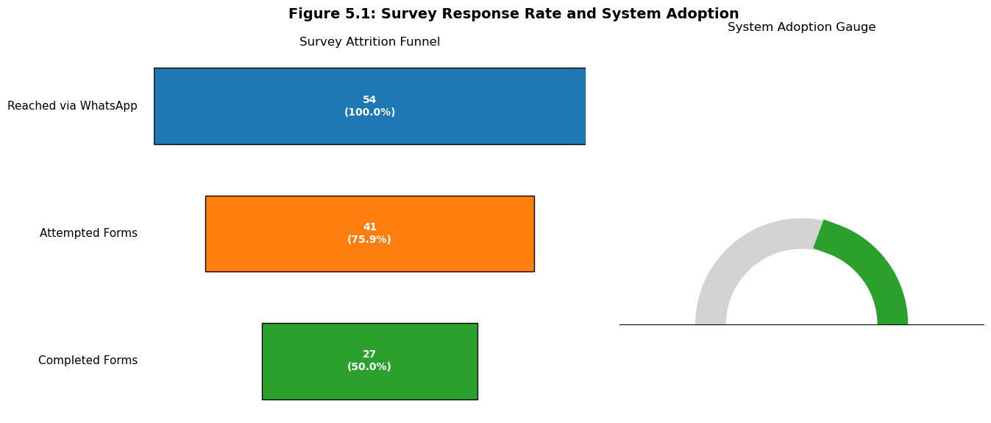

Figure 5.2: Modalities of Follow-up Interviews
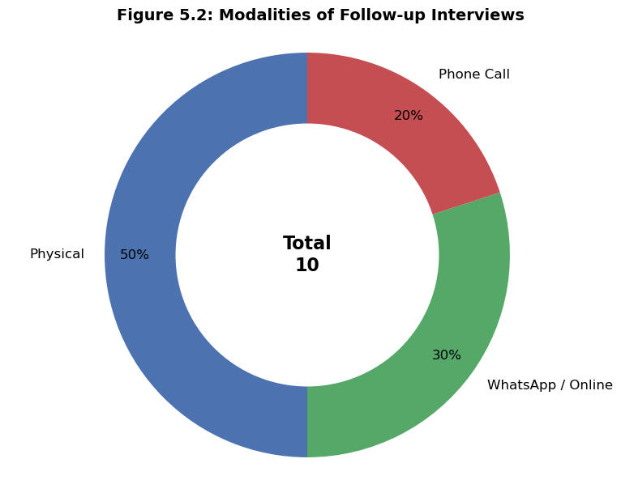

5.2 FINDINGS RELATED TO SYSTEM USAGE AND ACADEMIC DOCUMENT AVAILABILITY
During the data collection process, a prominent theme emerged from the 10 interviews: students expressed significant concern regarding data privacy. Participants were particularly anxious about how the academic data they provide to the system would be used, stored, and secured. Addressing these privacy concerns is critical, as it directly affects the students' willingness to upload their personal documents.

Despite these concerns, the survey revealed that students possess various academic documents that the Large Language Model (LLM) can analyse. The respondents indicated they could provide documents such as academic transcripts, certificates, project reports, and past assignments to help the system accurately extract their technical skills.
Figure 5.3: Qualitative Feedback on Data Privacy and Security Concerns
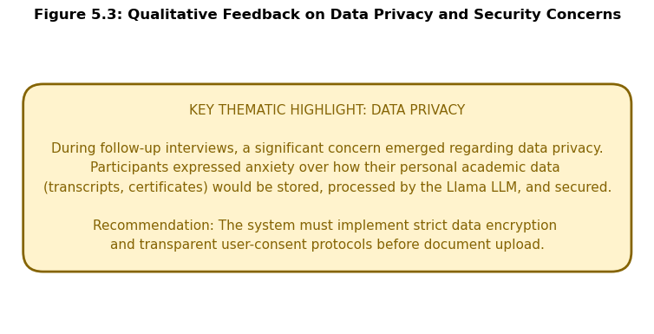

Figure 5.4: Availability of Academic Documents for LLM Analysis
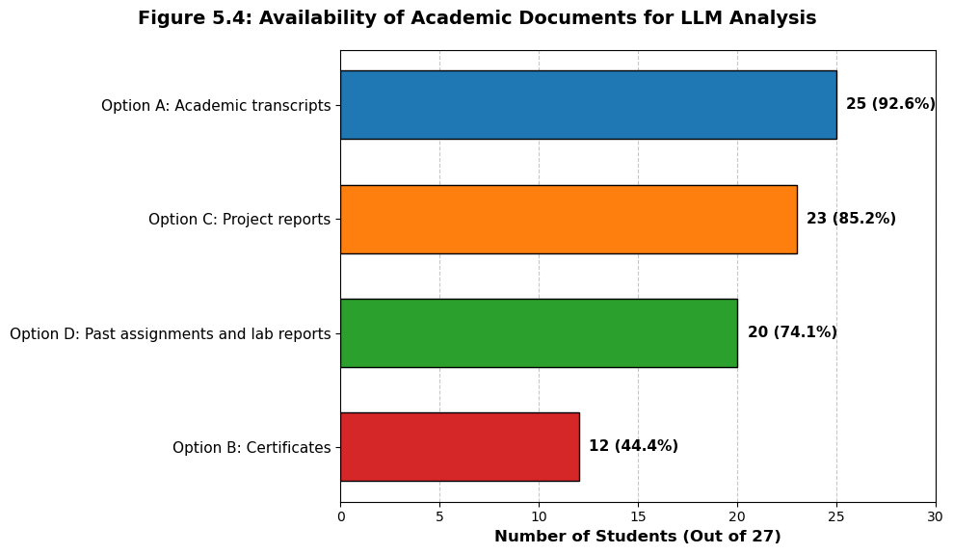

5.3 FINDINGS RELATED TO THE EMPLOYABILITY GAP AND SKILL TRANSLATION
The findings confirmed a significant disconnect between theoretical classroom learning and practical application. Responses from the 5-point Likert scale (where 1 is Strongly Disagree and 5 is Strongly Agree) highlighted that many students struggle to turn their classroom learning and academic projects into specific services for the job market. Furthermore, a notable number of respondents lacked confidence in their ability to package their university degrees into freelance work within the gig economy. For instance, some students noted that their biggest challenge is translating academic knowledge into practical value for employers or clients.

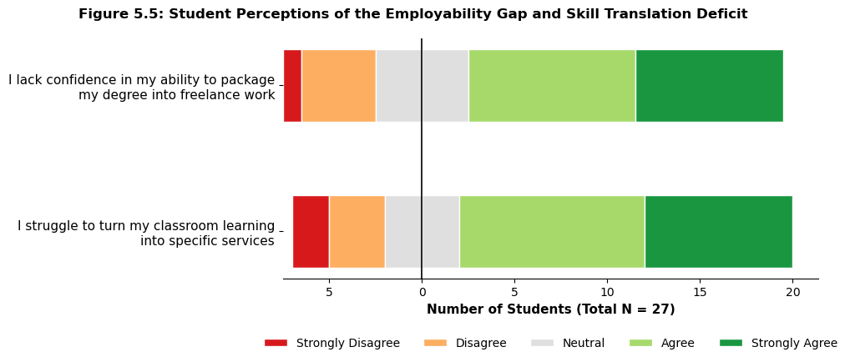
Figure 5.5: Student Perceptions of the Employability Gap and Skill Translation Deficit

5.4 FINDINGS RELATED TO DASHBOARD FUNCTIONAL REQUIREMENTS AND PERCEIVED VALUE
When asked about the visual profile dashboard, students identified several key features they deemed most important. These preferences included a clear visualisation of their professional identity, a specific list of technical skills extracted from their coursework, concrete marketable services they can offer, and suggestions on freelance pricing.

The findings also strongly supported the Theory of Perceived Value. Students agreed that using a digital business incubator tool to build a professional profile would increase the perceived value of their higher education and make them feel more "market-ready" by visualising their skills as actionable services.

Figure 5.6: Preferred Functional Requirements for the Profile Dashboard

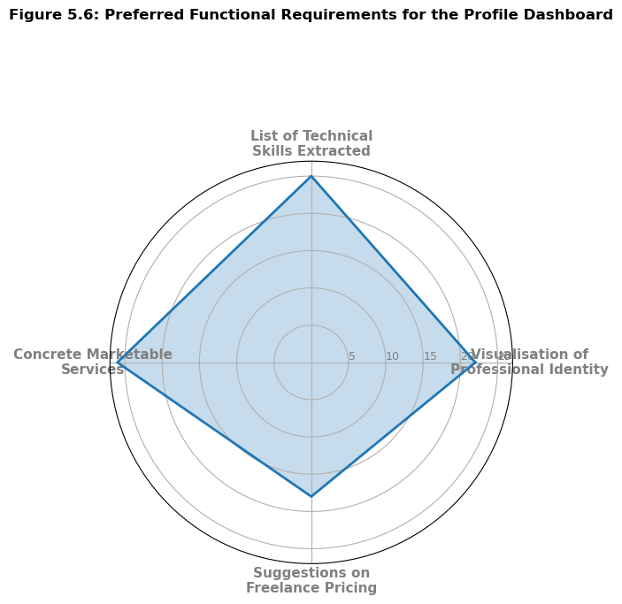
Figure 5.7: Impact of the System on the Perceived Value of Higher Education

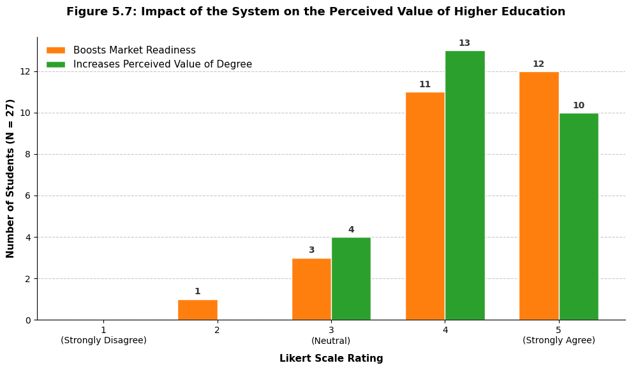

5.5 SUMMARY OF KEY FINDINGS
The data analysis revealed a strong level of initial interest and engagement with the proposed Intelligent Graduate to Job Mapping System. Out of the 41 questionnaires distributed to the target student demographic, 27 were successfully completed, yielding a solid response rate of 65.8%. Furthermore, early system adoption was highly encouraging, evidenced by 32 successful student sign-ups to the platform. To supplement this quantitative data, 10 follow-up interviews were conducted across various modalities to ensure diverse participation (5 physical, 3 online, and 2 via phone call).

Despite the high engagement, a primary barrier identified during the qualitative interviews was a significant concern regarding data privacy. Students expressed strong hesitation and anxiety about how their sensitive academic data such as transcripts, certificates, project reports, and past assignments would be stored, secured, and processed by the system's Llama LLM. However, the survey confirmed that students do possess these vital documents and are willing to upload them, provided that the system implements strict data encryption and transparent user-consent protocols.

Ultimately, the findings overwhelmingly validated the system's core conceptual framework and the problem it aims to solve. Both the survey respondents and interviewees confirmed a prevailing 'employability gap,' noting a widespread struggle to translate theoretical university coursework into practical, marketable skills for the gig economy. The consensus among participants was that an AI-driven digital career incubator, which visualises their academic capabilities into a professional dashboard (featuring technical skills, marketable services, and freelance pricing), would significantly boost their confidence, improve their market readiness, and increase the overall perceived value of their university degree.

6.0 CHAPTER SIX: SYSTEM IMPLEMENTATION

6.1 INTRODUCTION
This chapter outlines the practical implementation of the Intelligent Graduate to Job Mapping System. It details the user journey, from initial registration and navigation to the core functionality of uploading academic documents for Artificial Intelligence (AI) analysis. Finally, it demonstrates the system's final output: a personalised career mapping dashboard that translates academic coursework into actionable, freelance-ready skills.

6.2 USER AUTHENTICATION AND ONBOARDING
Security and user privacy were highlighted as primary concerns during the data collection phase (Chapter 5). To address this, the system begins with a secure authentication process powered by Firebase.

Using Firebase Google authentication users can automatically sign in into the system using their Google account. Once registered, returning users can securely sign in to the platform. This ensures that all uploaded academic documents and generated profiles are kept strictly private and accessible only to the account owner.

Figure 6.1: System Registration Interface.
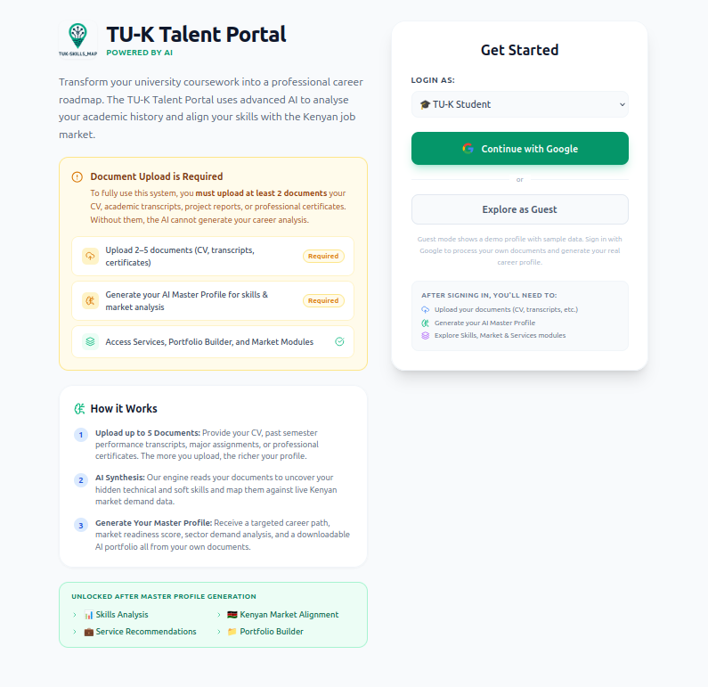
The user registration page where students input their name, email, and institution to securely create an account.

Figure 6.2: Secure User Login Interface.

The login portal allowing returning students to securely access their personalised accounts using their credentials or Google Authentication.

6.3 SYSTEM NAVIGATION AND INITIALISATION
Upon successful login, the user is greeted by a clean, user-friendly landing page. The design principles focus on simplicity to ensure students are not overwhelmed. The welcome screen provides a brief overview of the platform's purpose bridging the gap between classroom learning and career readiness. From here, the user can initiate the skill-mapping process by clicking the primary call-to-action button to get started.

Figure 6.3: Welcome Landing Page and Navigation.
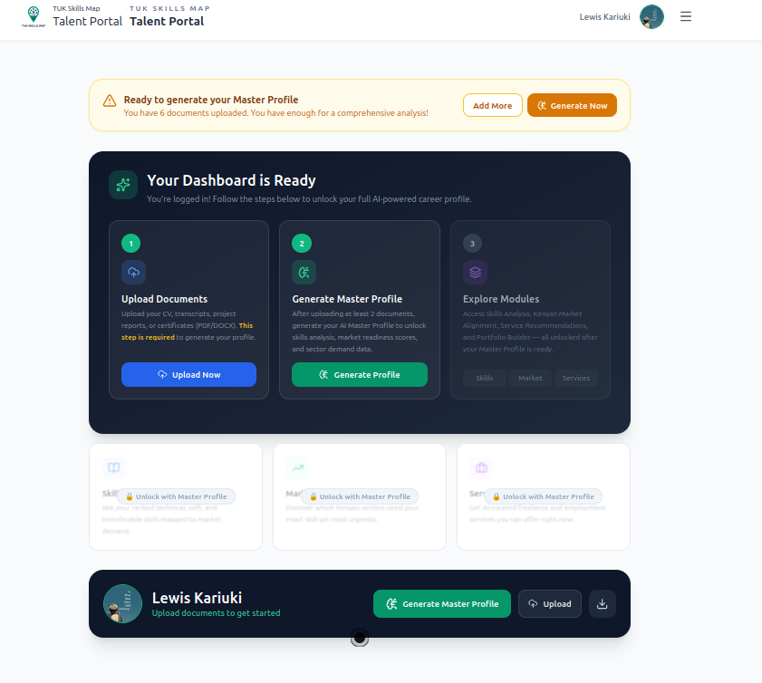
The initial dashboard welcoming the student, featuring a clear "Get Started" button to begin the skill mapping journey.

6.4 DATA INPUT AND AI PROCESSING
The core functionality of the system takes place in the document upload section. Users are prompted to upload their academic records, such as university transcripts, project reports, or certificates, in PDF format. The interface features a simple drag-and-drop area for ease of use.

Once a document is uploaded, the system immediately begins processing the data. Using the integrated Llama Large Language Model (LLM), the system analyses the text within the academic documents to extract core competencies, theoretical knowledge, and practical skills. During this phase, the user is presented with a loading state indicating that the AI is actively analysing the document, ensuring transparency in how the system works.

Figure 6.4: Academic Document Upload and AI Analysis.
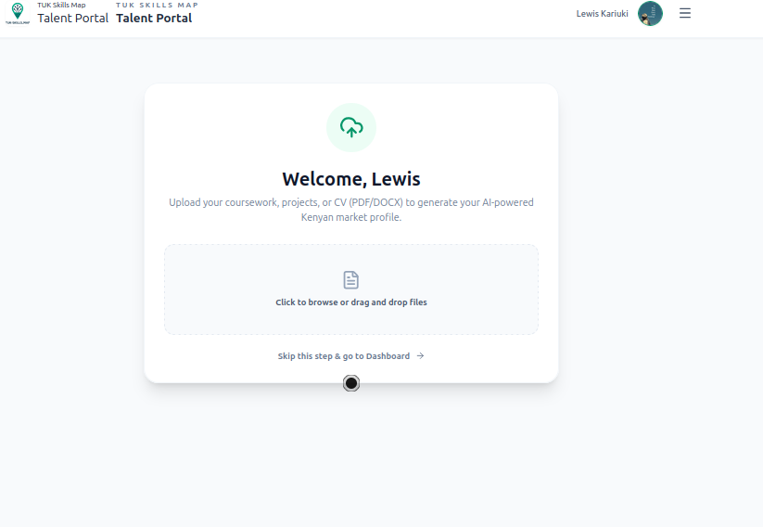
The document upload interface showing a drag-and-drop feature and the active AI processing state as the Llama LLM analyses the uploaded academic records.

6.5 SYSTEM OUTPUT: THE CAREER MAPPING DASHBOARD
After the AI finishes processing the academic documents, the system generates the final output: The Career Mapping Dashboard. This fulfils the primary functional requirement requested by the students in the survey.

The dashboard translates the often abstract academic jargon from transcripts into a concrete, professional identity. It is divided into several visual components:

Extracted Skills: A clear, bulleted list of technical skills the AI identified from the coursework (e.g., Data Analysis, Python, SQL).
Marketable Services: Suggestions on how to package these skills into specific freelance roles or services (e.g., Data Analyst, Freelance Developer).
Market Insights and Pricing: Actionable intelligence showing the demand for these roles and suggestions for freelance pricing (estimated hourly rates), empowering the student to enter the gig economy immediately.

Figure 6.5: The Career Mapping Dashboard Output.
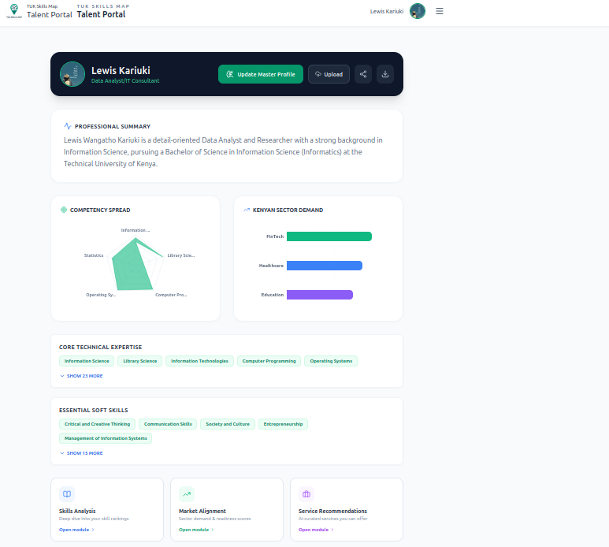
The main dashboard displaying the extracted technical skills, matched marketable services, and market insights based on the student's academic profile.

Figure 6.6: Recommended Roles and Freelance Pricing.
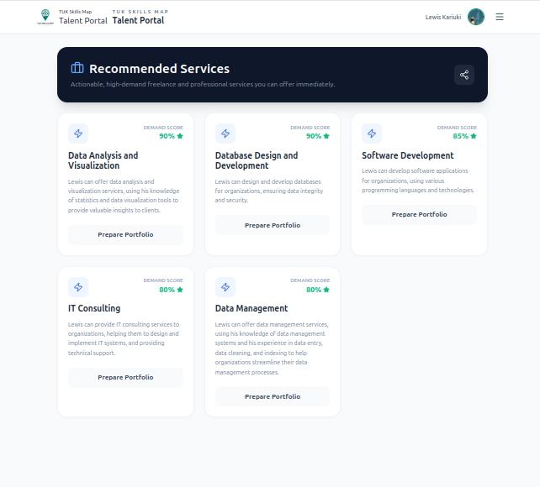
A detailed view of the dashboard providing concrete freelance role recommendations alongside estimated hourly pricing to boost the student's market readiness.

6.6 SUMMARY
The implemented system successfully translates the conceptual framework into a functional, user-centric web application. By employing secure authentication, a streamlined upload process, and advanced LLM text analysis, the platform effectively turns academic transcripts into actionable career dashboards. This directly addresses the employability gap by visualising a student's capabilities as ready-to-sell services for the modern gig economy.

REFERENCES

Adekunle, S. A. (2025). Gig work and career intention among university students. Global Journal of Management and Business Research. Retrieved from https://www.researchgate.net/publication/39374516
Amado, M., Guzmán, A., & Juarez, F. (2023). Relationship between perceived value, student experience, and university reputation: Structural equation modelling. Humanities and Social Sciences Communications, 10(780). https://doi.org/10.1057/s41599-023-02272-y
Đorđević, B., Milanović Zbiljić, S., & Radosavljević, M. (2025). Impact of digital skills on employability: Cross-sectional analysis. Economies, 13(7), 196. https://doi.org/10.3390/economies13070196
Feraco, T., & Toffalini, E. (2024). SEMbeddings: how to evaluate model misfit before data collection using large-language models. https://doi.org/10.31234/osf.io/kwrsg.
Iskandar, A. S., Wirawan, H., & Salam, R. (2024). Students' perceived value in higher education institutions: Investigating the role of antecedents and context. Cogent Business & Management, 11(1), 2313789. https://doi.org/10.1080/23311975.2024.2313789
Jackson, D., et al. (2024). Student employability-building activities: Participation and contribution to graduate outcomes. Higher Education Research & Development. https://doi.org/10.1080/07294360.2024.2325154
Jones, O., Meckel, P., & Taylor, D. (2021). Situated learning in a business incubator: Encouraging students to become real entrepreneurs. Industry and Higher Education, 35(3). https://doi.org/10.1177/095042222110081
Kimeu, P. (2019, April 4). What’s next after Campus? FOCUS Kenya. https://www.focuskenya.org/what_next_after_campus/
Kolb, D. A. (1984). Experiential learning: Experience as the source of learning and development. Prentice-Hall. Retrieved from https://www.researchgate.net/publication/235701029_Experiential_Learning_Experience_As_The_Source_Of_Learning_And_Development

Njeru, O. (2023, February 20). Embracing endings: Reflections of recent graduates on redefining success. Nation Africa. Retrieved from https://nation.africa/kenya/life-and-style/mynetwork/embracing-endings-reflections-of-recent-graduates-on-redefining-success-4801300
Technical University of Kenya. (2015). TU-K graduates most favoured by employers. Retrieved from https://tukenya.ac.ke/sites/default/files/downloads/tuk-favoured.pdf
Technical University of Kenya. (2025). 2025 graduation e-booklet. Retrieved from https://tukenya.ac.ke/images/2025/2025%20e-booklet.pdf
Wanjiru, P. (2025). Examining the character of the gig economy in Kenya: A case study of youth in Nairobi [Master's thesis, United States International University-Africa]. USIU-Africa Digital Repository. https://erepo.usiu.ac.ke/handle/11732/901
Facebook Open Source. (n.d.). React: A JavaScript library for building user interfaces. Retrieved from https://reactjs.org/
Google. (n.d.). Firebase Authentication. Retrieved from https://firebase.google.com/products/auth
Meta. (2024). Llama 3.2: Open and efficient foundation language models. Retrieved from https://ai.meta.com/llama/
MongoDB. (n.d.). MongoDB: The developer data platform. Retrieved from https://www.mongodb.com/
Node.js Foundation. (n.d.). Node.js: JavaScript runtime built on Chrome's V8 engine. Retrieved from https://nodejs.org/
Ollama. (n.d.). Get up and running with large language models locally. Retrieved from https://ollama.com/
Recharts. (n.d.). A composable charting library built on React components. Retrieved from https://recharts.org/

